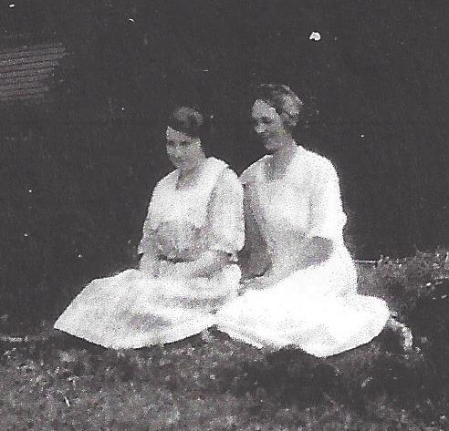

**Dorothy Elizabeth Wolfe List and Anna Worthen – about 1925**

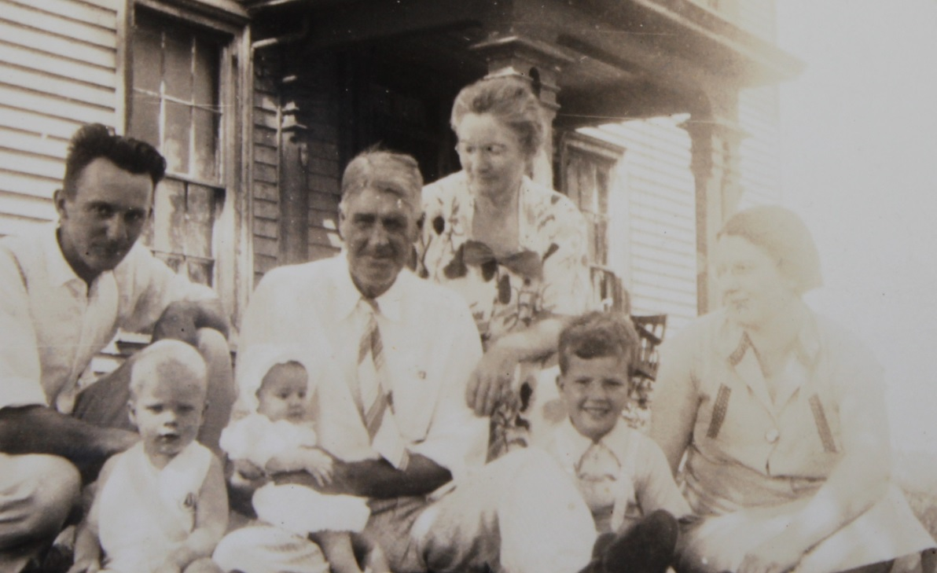

**Back row: Luther List, Earl R. Wolfe, Josephine Worthen Wolfe**

**Front row: David List, Dorothy (Dotty) List, Ronald List, Dorothy E. Wolfe List - 1937**